TJ, §§15-19

Review
- Democratic equality = substantive equality of opportunity + the difference principle

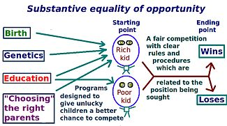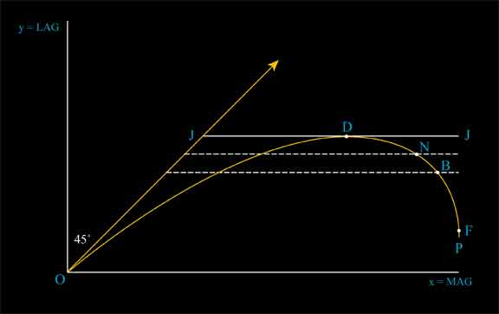

Are there any questions about Rawls’s graphs? About the argument for democratic equality?

  - Explain perfect, imperfect and pure procedural justice, giving examples of each. Why is it desirable to leave distribution to pure procedural justice? (see p. 76)

Section 15
- What are interpersonal comparisons, and what are the difficulties of making them? What is the difference, alluded to at the top of p. 79, between ordinal and cardinal comparisons?

- What are primary goods? (p. 79, but see also p. 54) What is the “index problem” (p. 80)? How does the adoption of primary goods as the measure of wellbeing, together with the difference principle, simplify it?

- Explain the important remarks at the bottom of p. 79 about the theory of good adopted to account for the primary goods, and about the nature of happiness. (HINT: Be prepared to explain the idea of a rational plan.)

  - Rawls says that the good is the satisfaction of rational desire. How, then, does his account of goodness and happiness differ from that of the utilitarian?

  - What does Rawls mean by saying that we don’t look into the use people make of primary goods? That we don’t compare the worth of plans of life?

Section 16
- What is a representative individual? What does Rawls mean by saying that everyone occupies two social positions? Why use the position of equal citizenship if at all possible?

Section 17
- What is the Principle of Redress?

  - Explain why the Principle cannot be the sole principle of justice.

  - Explain how the Difference Principle takes into account but differs from it.

  - Note that both the DP and the Principle of Redress are motivated by Rawls’s construal of equality of opportunity.

- Note how Rawls tries to accommodate our intuitions about the value of education on pp. 87, 92.
- What does Rawls mean by saying that the DP represents an agreement to regard the distribution of talents as a common asset?

  - Explain “The social system is not an unchangeable order beyond human control but a pattern of human action.” What is the significance of this remark for how we should regard the distribution of talents?

- Note the argument at p. 88, which turns on the claim that to reject the DP is to reward the talented twice over.

  - Note that the argument appeals to the grounds on which the talented or well-endowed could expect the willing cooperation of the less favored. In point of fact, it is arguable – and is argued in this article -- that the less favored enter into a somewhat less beneficial social contract with the elite: they will cooperate with the elite, and allow them to gain, provided they are on the upward sloping part of the contribution curve. What might Rawls say?

- Rawls sums up an important line of argument by saying “Thus it is incorrect that individuals with greater natural endowment and the superior character that has made their development possible have a right to a cooperative scheme that enables them to obtain even further benefits…” (p. 89) How does the argument go? Is it plausible?

  - The thesis that the difference people treats the talented unjustly by hindering their self-realization is one that is seems to have a great deal of intuitive appeal. Let’s think about the argument.

To fix ideas, read this story, according to which professional golfer Phil Mickelson may retire from competition because taxes on his winnings are so high. For those who do not follow golf, Mickelson would probably win a lot more tournaments if he continued to play instead of retiring, so the decision to quit playing under the pressure of high taxes would keep him from realizing his full potential.

      - Do the tax rates to which Mickelson is subject hinder his self-realization?

      - Does Mickelson have a right – i.e. a claim of justice -- to the self-realization that come from developing his talents to their full potential?

      - Do the tax rates therefore wrong Mickelson – i.e. do they constitute an injustice toward him?

- What is a meritocratic society? Is America in danger of becoming one – before you answer, read a disturbing column by David Brooks of the New York Times.

  - IQ is usually thought to be normally distributed. If the marriage patterns Brooks identifies persist, what will the distribution of inherited talent – as measured by IQ, say -- look like in the US? A bell curve? A bimodal distribution?

  - What does Rawls mean by saying “I mention this … matter to indicate once again the manner in which the difference principle is likely to transform problems of social justice”?

  - Consider, in this connection, Rawls’s argument that the difference principle will lead to a kind of fraternity. Can it heal the “great divorce” to which Brooks refers?

Sections 18 and 19
- Why choose principles for institutions first?
- What defines an obligation?

  - What is the principle of fairness?

  - Why does Rawls say that ordinary citizens are not under political obligations? (p. 98)

  - Explain: “The reason why obligations depend upon voluntary acts is given by the second part of the principle of fairness… It has nothing to do with the contractual nature of justice as fairness.” (p. 99)

- What are the natural duties?
- What is the supererogatory and why can’t utilitarianism accommodate it?

